|  |  |
| --- | --- |
| Power BI Lab Day 2 Document | |
|  |  | | |
| **Writer:** | I&D Microsoft | | **Initials entity:** |
| **Date creation:** 26/04/2018 | |  | **Last upgrade:** 26/04/2018 |

Power BI LAB DOCUMENT

DAY 2- Lab 1

|  |  |  |  |  |
| --- | --- | --- | --- | --- |
| Version | Author | Comment | Reviewed By | Date |
| V 1.0 | I&D Microsoft | Initial draft | Moupiya Das |  |
|  |  |  |  |  |
|  |  |  |  |  |

**Pre-requisites**

Installed and working Power BI Desktop setup.

**Environment Setup**

To install Power BI Desktop to your machine or to sign up for Power BI Service, Refer to Power BI Lab Exercise Day 1.

**Lab Overview**

This lab comprises of four tasks:

1. In the first task, you import the data from an excel sheet, data base, online services & azure services.

2. In the second task, you will edit queries using query editor.

3. In the third task, you will perform various transformations.

**Case Scenario**

The AdventureWorks Database is a sample database file which supports a fictitious, multinational manufacturing company called Adventure Works Cycles. The AdventureWorksdatabase excel sheet has 27 different sheets in total.

We will be importing 3 sheets to perform the various tasks in the Lab. We would be performing various data transformations on different types of data.

# Table of Contents

1. Import Data into Power BI? From,
   1. Excel Source ……………………………………………………………………………………………………………………………...4
   2. Database…………………………………………………………………………………………………………………………………….6
   3. Azure Services…………………………………………………………………………………………………………………………….8
   4. Online Services……………………………………………………………………………………………………………………………9
2. Data Transformations
   1. Choose Columns……………………………………………………………………………………………………………………….11
   2. Remove Columns………………………………………………………………………………………………………………………13
   3. Keep Rows…………………………………………………………………………………………………………………………….....16
   4. Split Column……………………………………………………………………………………………………………………………..17
   5. Group By…………………………………………………………………………………………………………………………….......18
   6. Use First Rows as Headers…………………………………………………………………………………………………………19
   7. Replace Values………………………………………………………………………………………………………………………….20
   8. Combine……………………………………………………………………………………………………………………………........22
   9. Transpose……………………………………………………………………………………………………………………………......23
   10. Reverse Rows……………………………………………………………………………………………………………………………24
   11. Count Rows……………………………………………………………………………………………………………………………...26
   12. Rename…………………………………………………………………………………………………………………………….........26
   13. Pivot Column…………………………………………………………………………………………………………………………….28
   14. Unpivot Columns………………………………………………………………………………………………………………………30
   15. Move…………………………………………………………………………………………………………………………….............31
   16. Convert to List…………………………………………………………………………………………………………………………..33
   17. Fill……………………………………………………………………………………………………………………………..................34
   18. Format (Lowercase, Uppercase, Capitalize Each Word, Add Prefix etc...)………………………………….35
   19. Extract (First Characters, Last Characters, Length, Range etc...)………………………………………………..36
   20. Statistics (Sum, Minimum, Maximum, Median, Average etc...)………………………………………………….37
   21. Standard (Add, Subtract, Multiply, Divide etc...)……………………………………………………………………….38
   22. Scientific (Power, Square Root, Absolute Value etc…)……………………………………………………………….39
   23. Rounding (Round Up, Round Down)………………………………………………………………………………………….40
   24. Information (Is Even, Is Odd and Sign) ………………………………………………………………………………………41
   25. Trigonometry (Sine, Cosine, Tangent etc…)……………………………………………………………………………….42
   26. Transform……………………………………………………………………………………………………………………………......43
   27. Change Type……………………………………………………………………………………………………………………………..46
   28. Duplicate Column……………………………………………………………………………………………………………………..47
3. Summary……………………………………………………………………………………………………………………………..............49

# Import Data into Power BI

1. **Excel Source:**

* Start with a blank Power BI Desktop file.
* Click on Get Data option in the ‘Home’ tab and choose Excel.

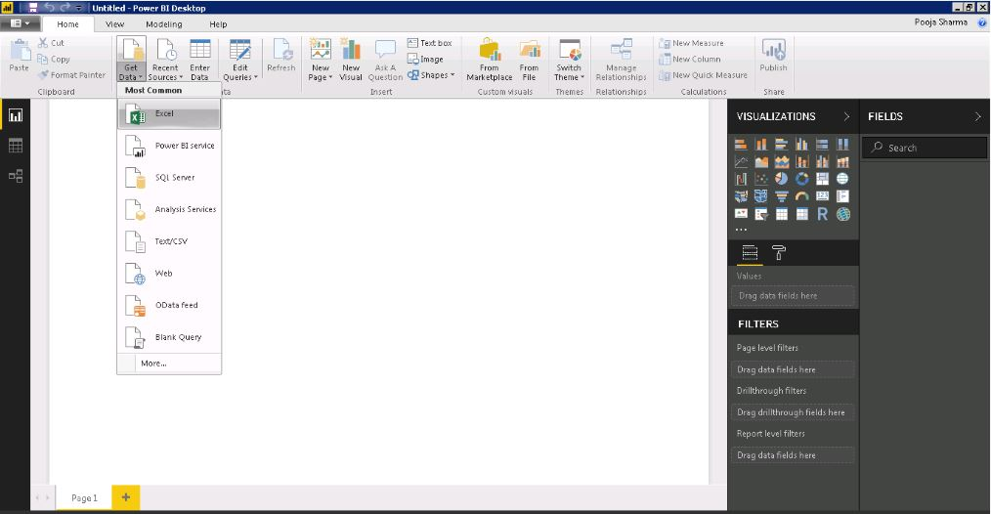

1. Select AdventureWorksDatabase, from the browse menu and click Open.

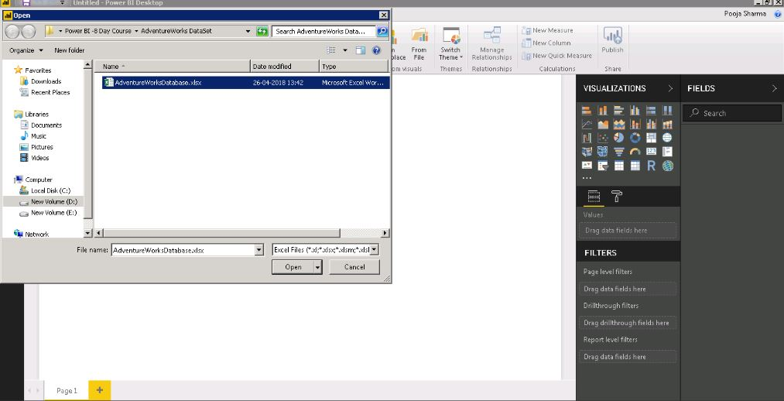

It would take a little time to connect to your database.

Select **DimEmployee** sheet to load data.

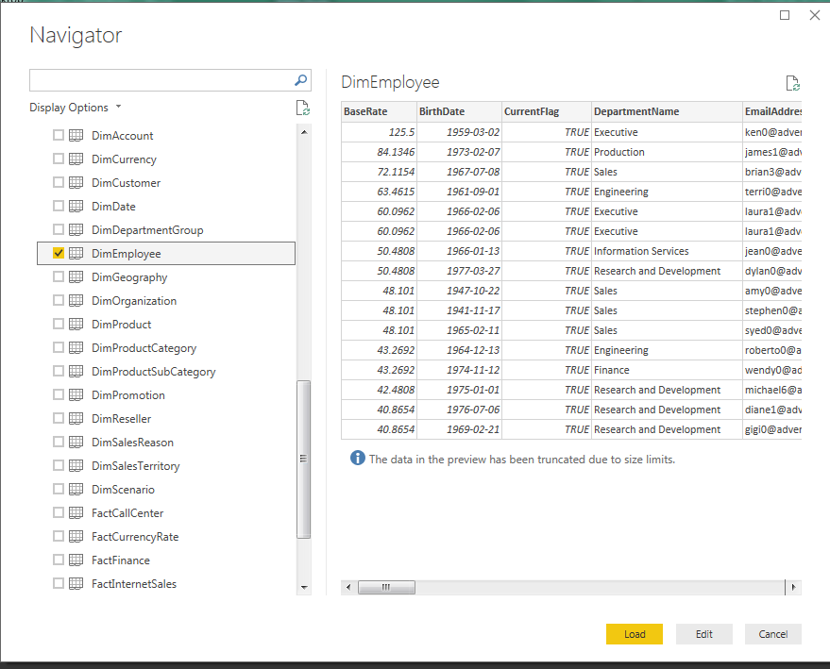

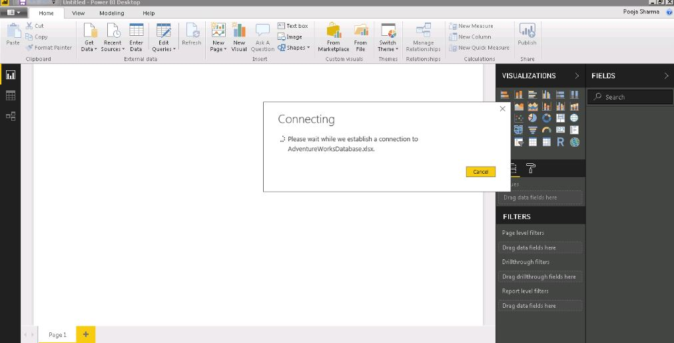

Data Set will be created as below:

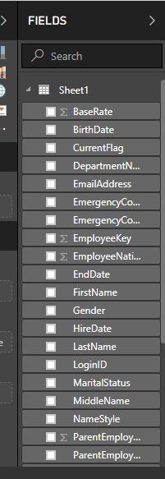

**2.DataBase:**

* Select Get Data and select DataBase as your source:

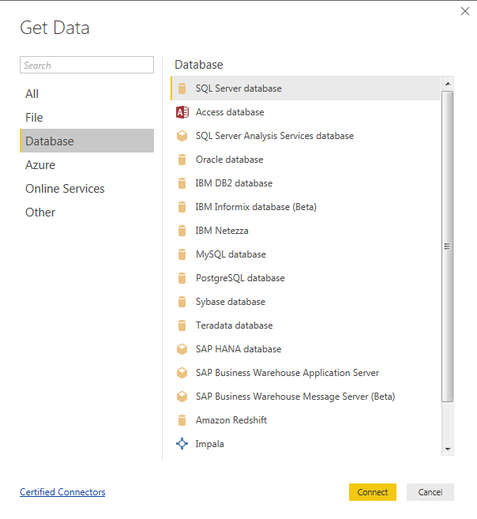

If you are on the list of all Data Sources, we want to select **SQL Server Database** and then click **Connect**.

You will then see a screen to enter the SQL Server name and the Database name. This would be where the data is going to come from.

*[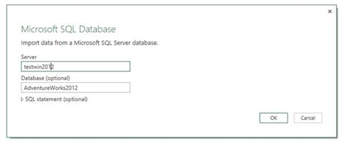](https://powerbicdn.azureedge.net/mediahandler/blog/legacymedia/clip_5F00_image006_5F00_663EAD9E.jpg)*

*[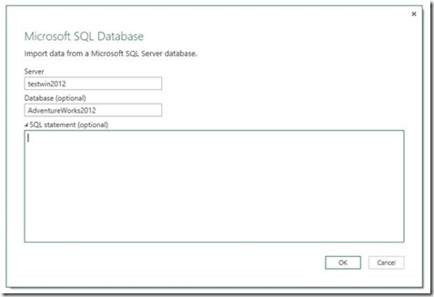](https://powerbicdn.azureedge.net/mediahandler/blog/legacymedia/clip_5F00_image008_5F00_15FC561E.jpg)*

*[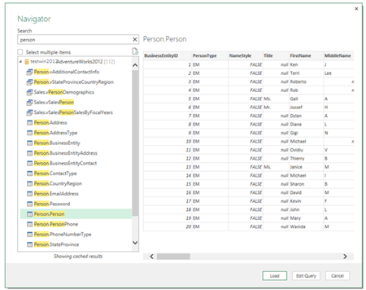](https://powerbicdn.azureedge.net/mediahandler/blog/legacymedia/clip_5F00_image009_5F00_5EB5CEE2.png)*

Once you have selected the item, click **Load**. This will pull the data into the Data Model.

*[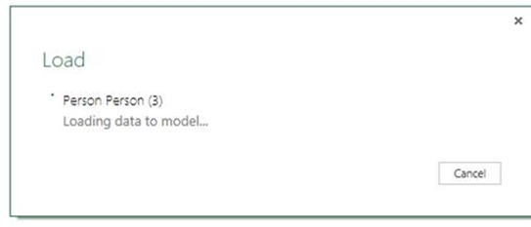](https://powerbicdn.azureedge.net/mediahandler/blog/legacymedia/clip_5F00_image011_5F00_69E1E9DD.jpg)*

**3.Azure Services:**

* The following image shows the **Get Data** window for **Azure**.

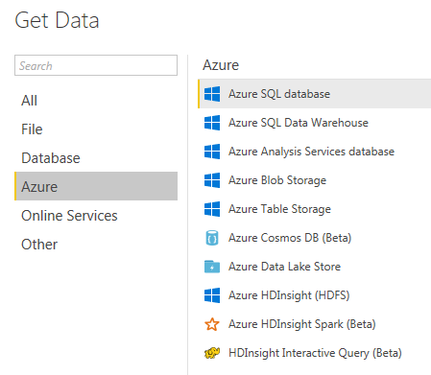

* You can either import data or use Direct Query to connect to azure database.

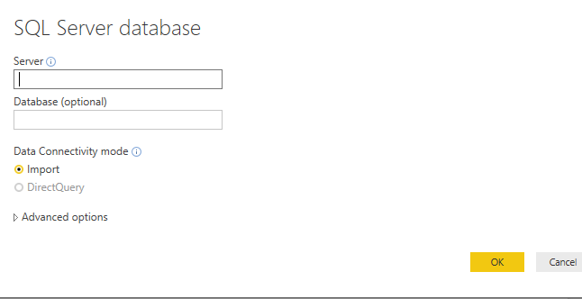

**4. Online Services:**

To establish a connection to the published report, and create your own report based on the published dataset, select **Get Data** from the **Home** ribbon in **Power BI Desktop**, and select **Power BI service**. You can also select it from **Get Data > Online Services > Power BI service**.

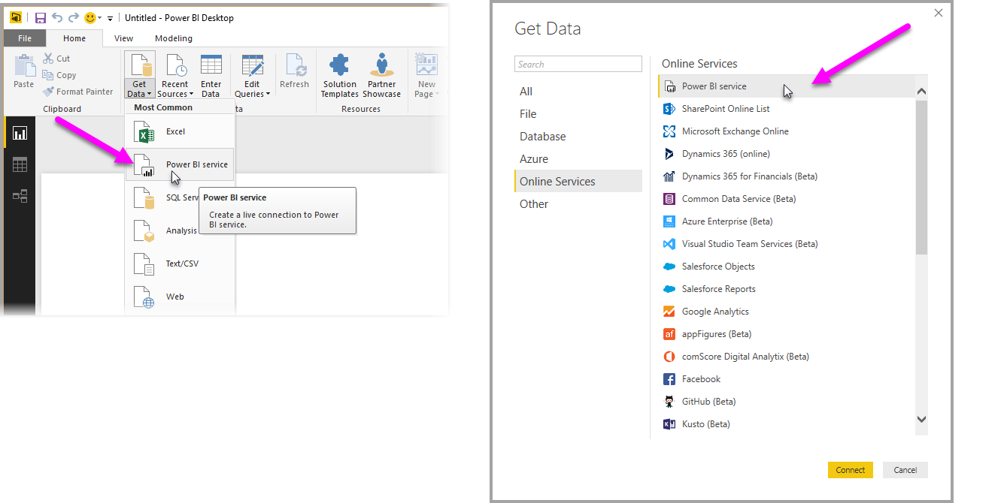

When you select **Load** from the window, you establish a live connection to the selected dataset, which means the data you see (the fields, and their values) are loaded into **Power BI Desktop** in real time.

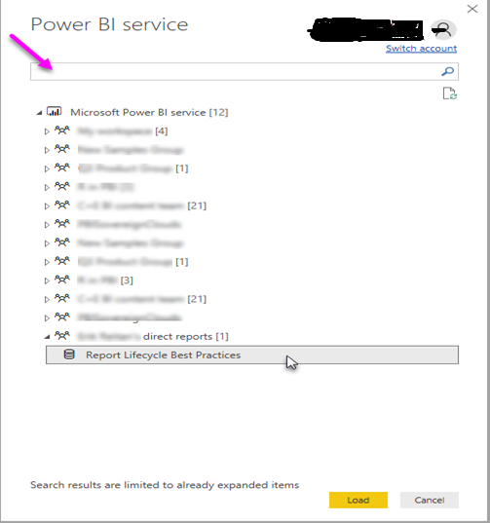

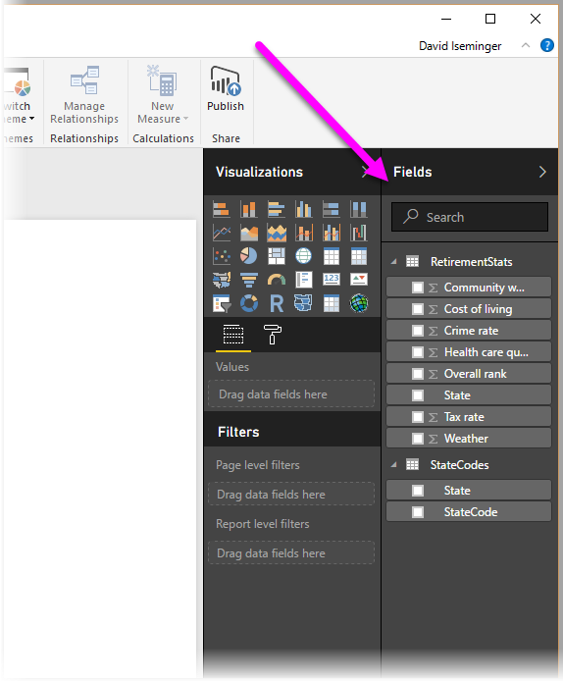

**2.Data Transformations in Power BI:**

* **Import the DimEmployee, FactInternetSales, DimProductSubcategory data from the excel sheet as shown in Step 1 of Importing Data From Excel.**
* Open the query editor as shown below for doing all the transformations:

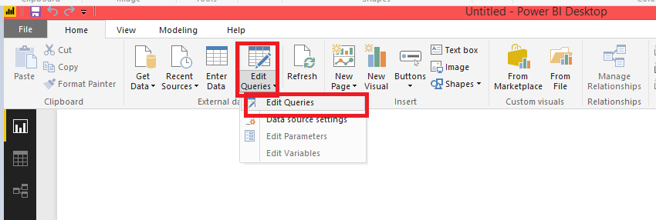

**1. Choose Columns:**

* Select Choose Column from the menu bar above :

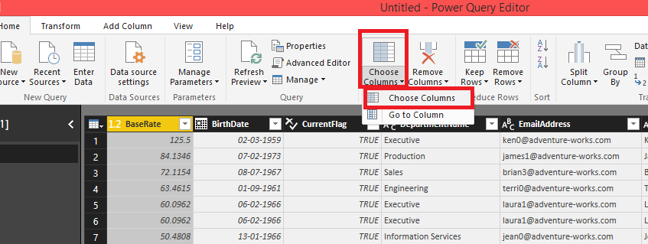

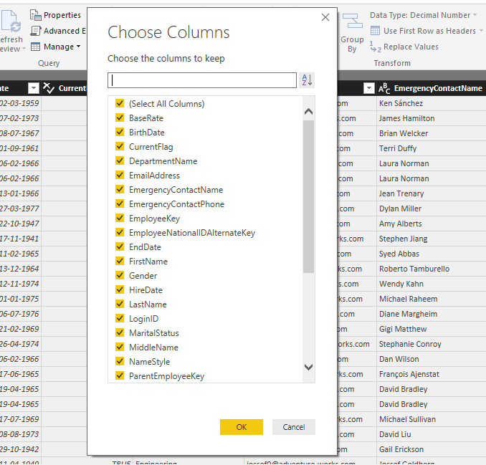

* Choose Selected Columns :

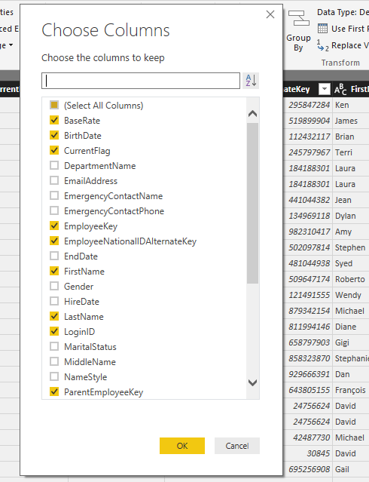

The result would be:

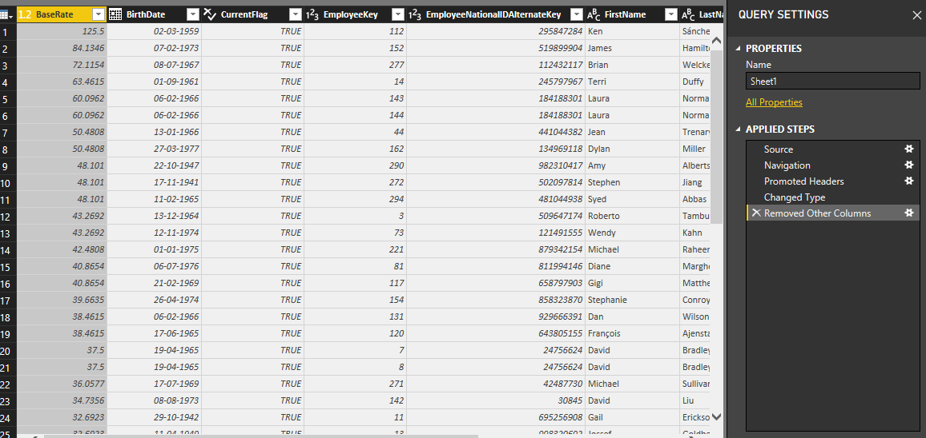

**2. Remove Columns:**

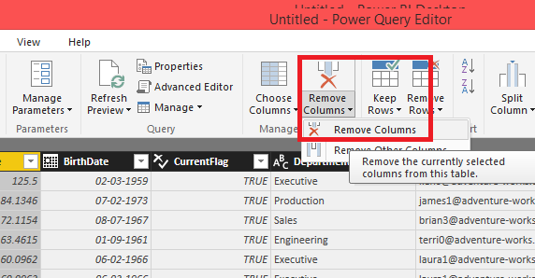

* Selecting Employee Key Column to be removed:
* The column does not appear as shown below:

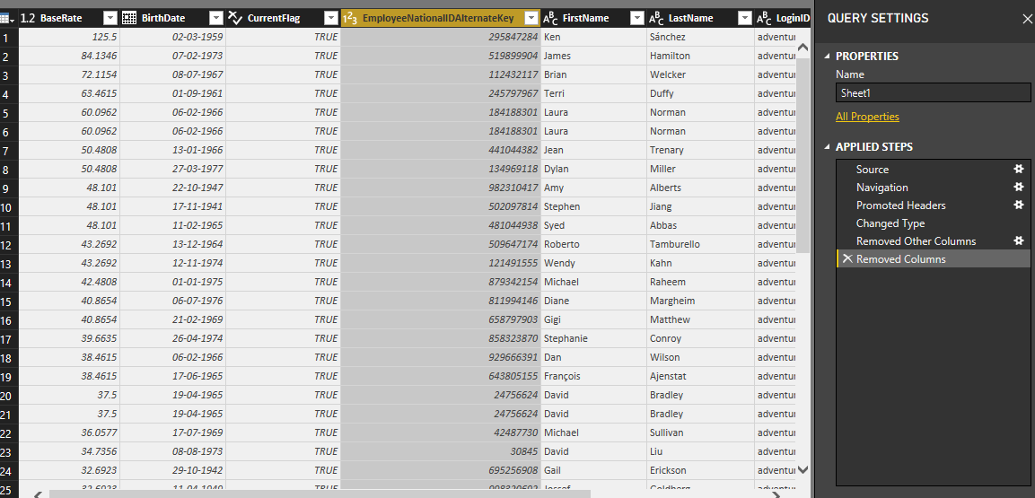

* Now,let's look at another example of a Fact Table:
* Take **FactInternetSales** dataset.

* Now we do not need all the columns from the fact table.
* So let's remove the columns "CarrierTrackingNumber", "PromotionKey", "RevisionNumber".
* Select the column "CarrierTrackingNumber","PromotionKey", "RevisionNumber" and then click Remove Columns.

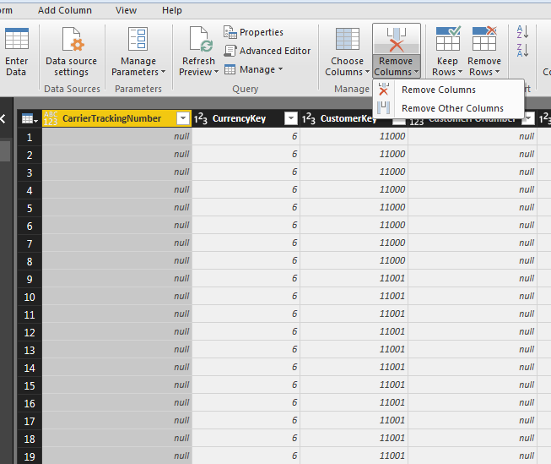

* The columns are removed.

**3. Keep Rows:**

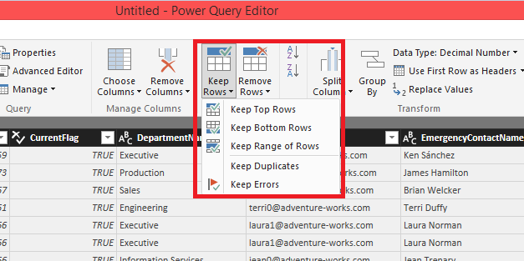

* Selecting Keep top rows, we get:

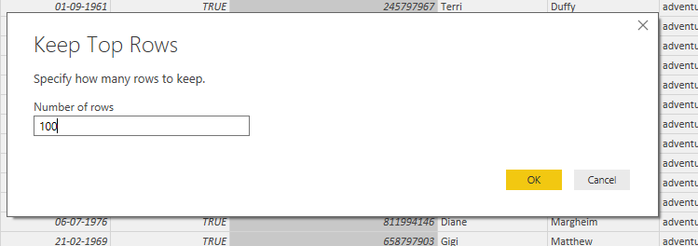

* The top 100 Rows remain.

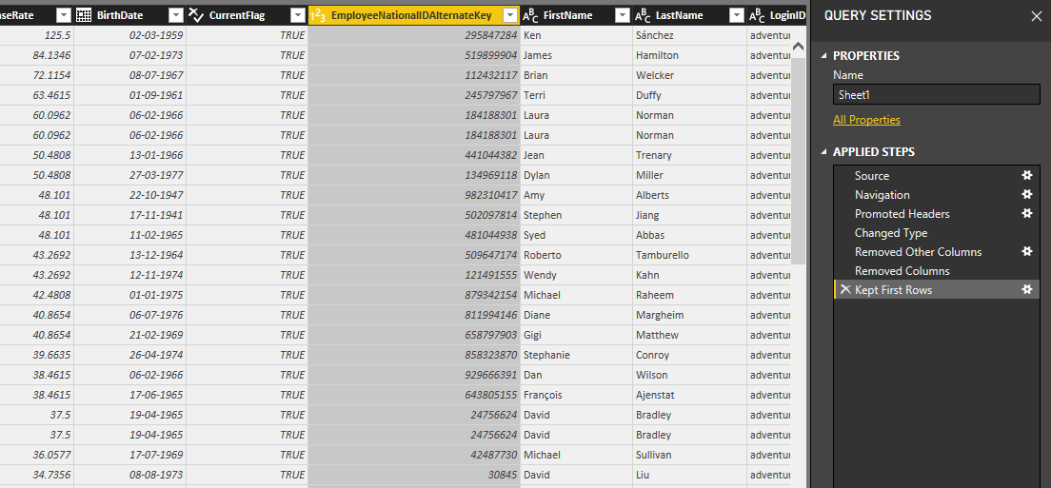

**4. Split Column:**

* If we need to split the login ID column into to domain name and user id, follow the below steps:

i. Select the column to be split and choose Split Column by Delimiter:

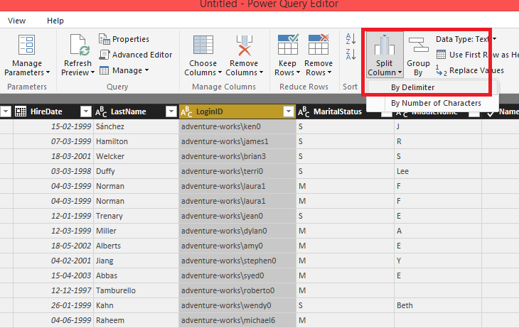

ii. The following dialogue box appears.

Enter the Delimiter '\'

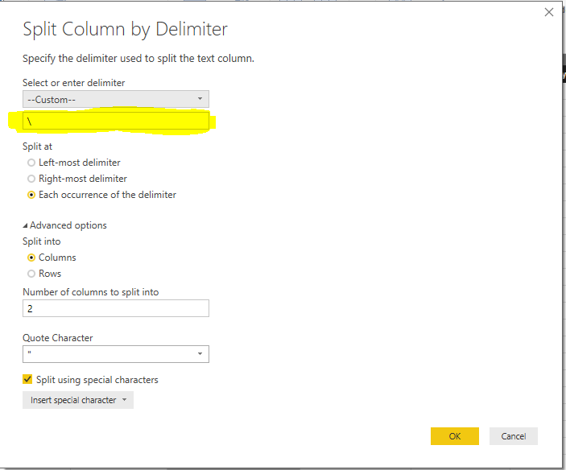

iii. Now as we can see the **LoginID** column has been split into 2 different columns

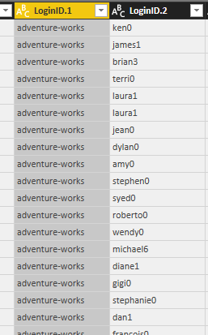

**5. Group By:**

* In this we have Group by Gender:

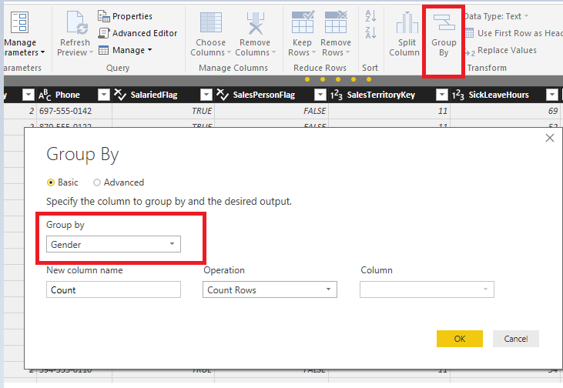

The results are as below:

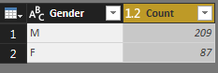

The transformations from 1-5 are attached below:



**6. Use First Rows as Headers:**

* Import DimEmployee as shown in Section 1.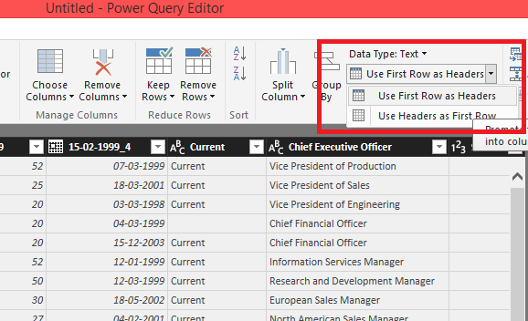

Before applying transformation the headers are as follows:

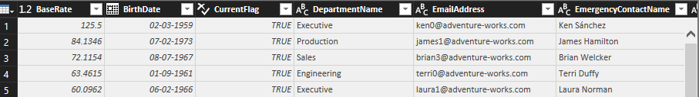

After applying transformation, the first row becomes the header:

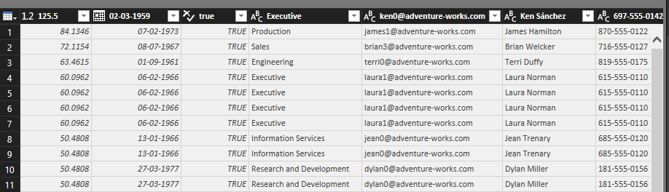

**7. Replace Values:**

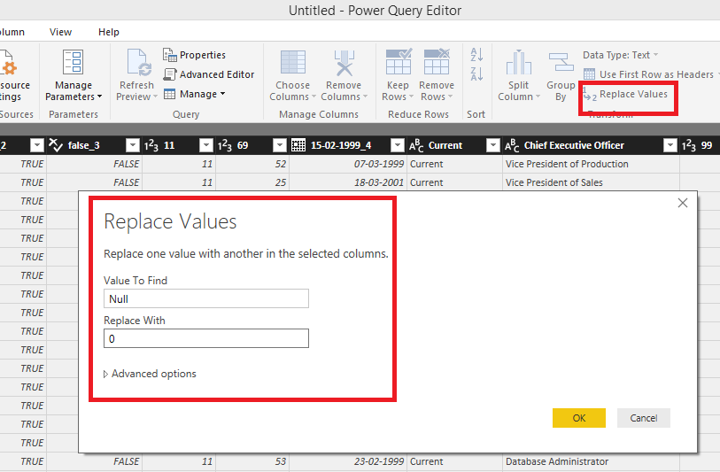

* Here we are replacing the Null values in **Department Name** column with No department:

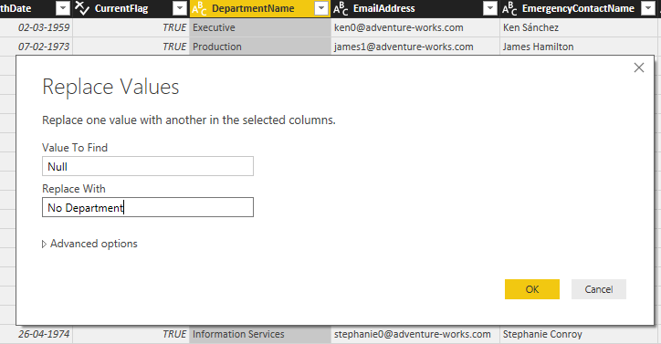

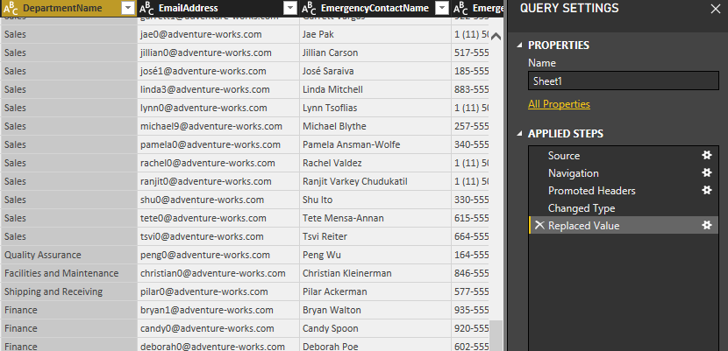

**8. Combine:**

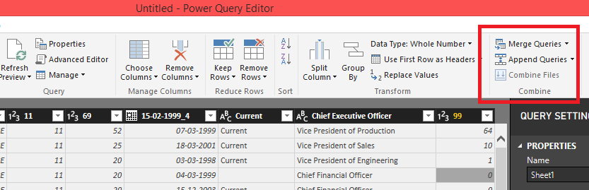

Now apply merge transformation:

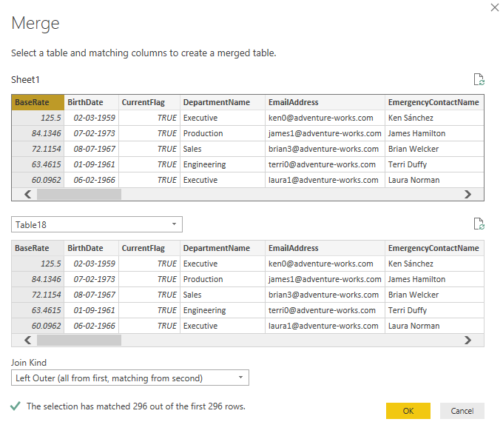

Now as you can see the column base rate has been added: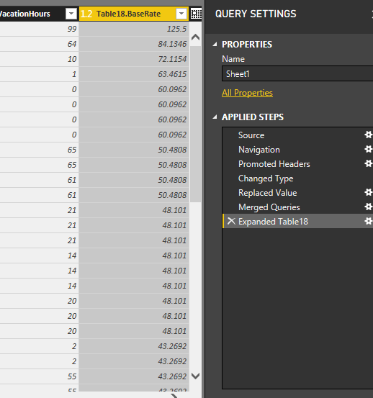

**9. Transpose:**

* Go in Transform tab up in the menu bar. Select Transpose.

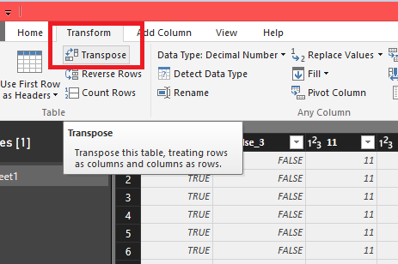

Before applying transpose:

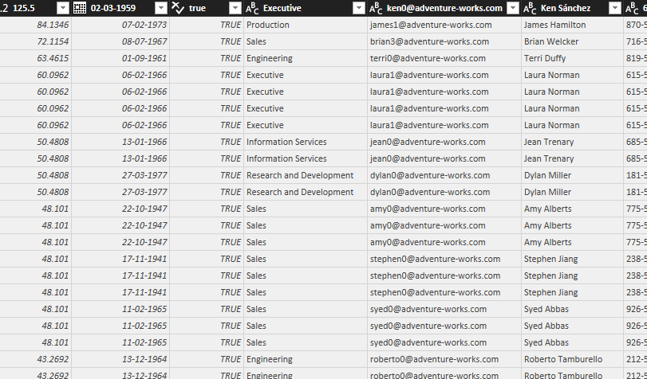

After applying:

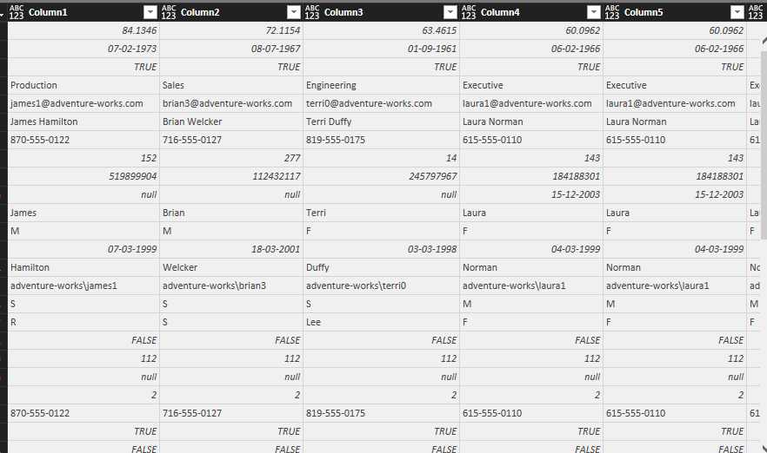

**10. Reverse Rows:**

* Select Reverse Rows from Transform tab.

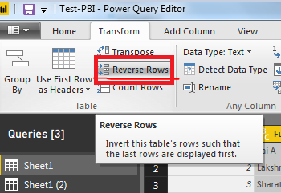

After transpose and applying reverse:

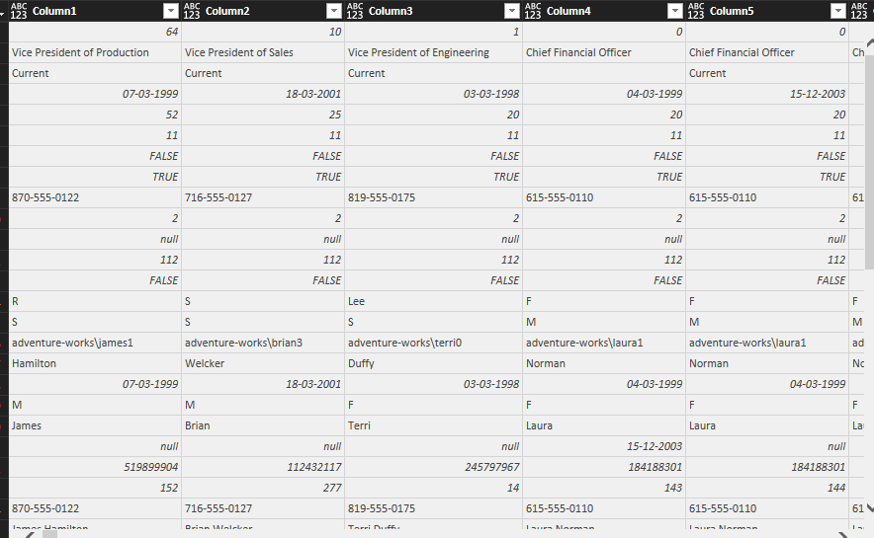

Transformation 6-10:



**11. Count Rows:**

* Import **DimEmployee** as shown in Section 1.

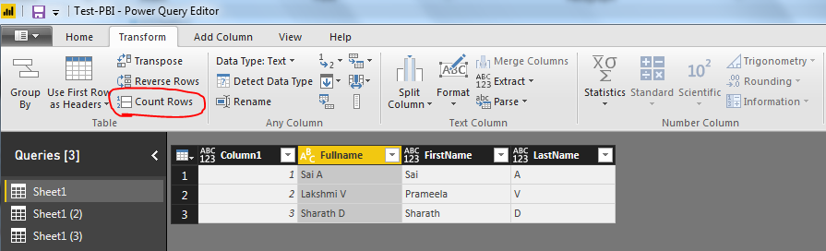

**Result:**

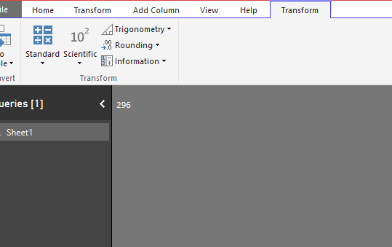

**12. Rename:**

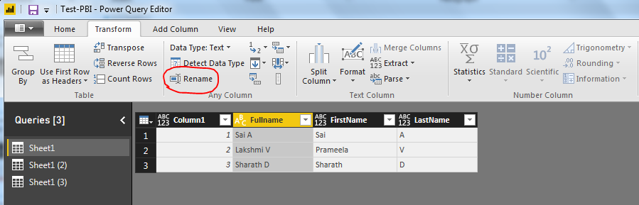

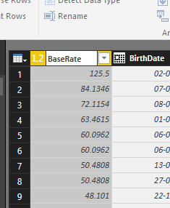

After Renaming the **BaseRate** column:

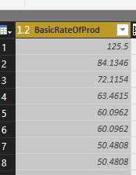

* Now,let’s take **DimProductSubcategory** data set as another example of renaming columns
* Let’s rename the column **EnglishProductSubcategoryName** to **ProductSubcategory**:

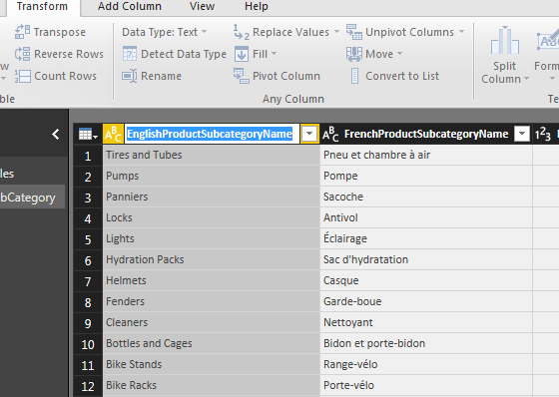

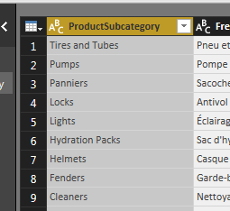

**13. Pivot Column:**

* Use Pivot Column on **BirthDate**.

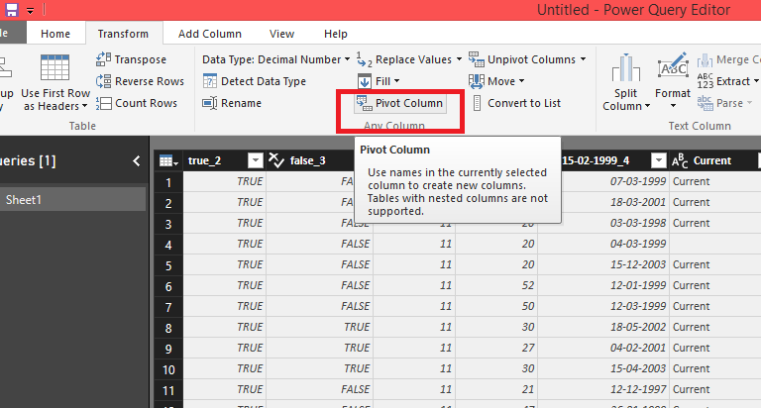

**Before:**

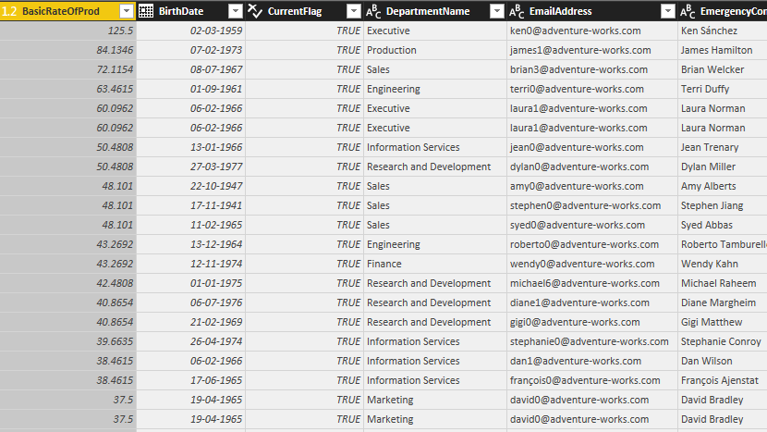

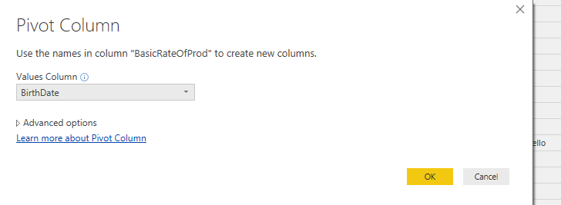

**After:**

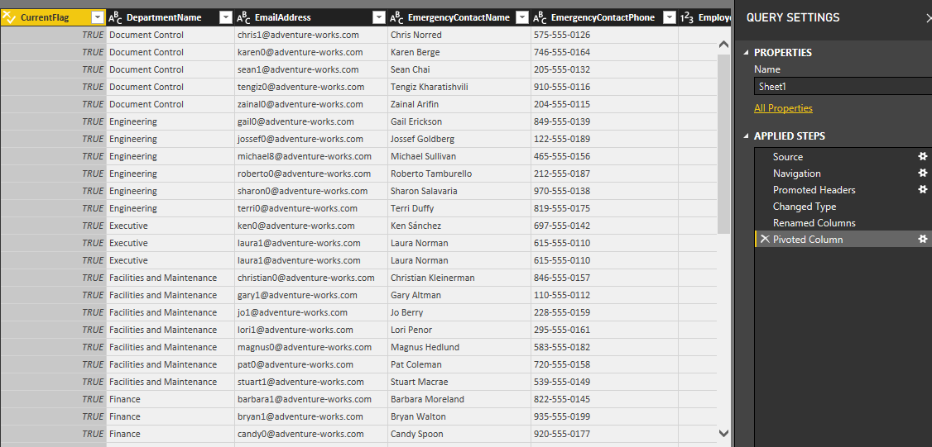

**14. Unpivot Columns:**

* Unpivoting the previously pivoted columns.

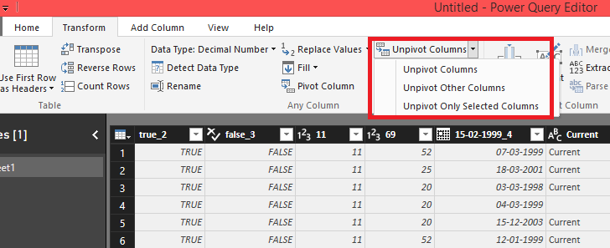

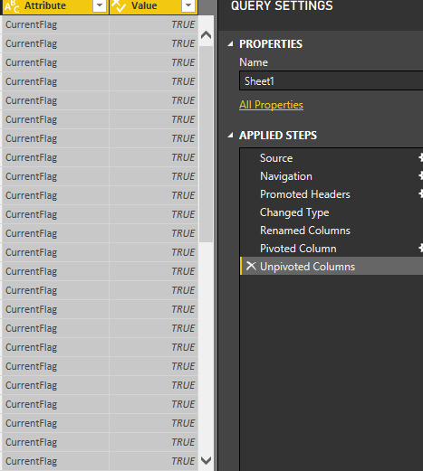

**15. Move:**

* Select a column and then Click Move and now you can move that column to any given position as shown below:

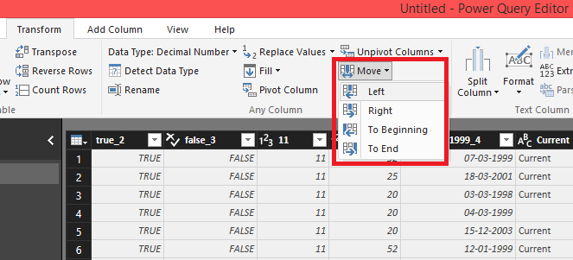



After applying move to beginning for Attribute and value:

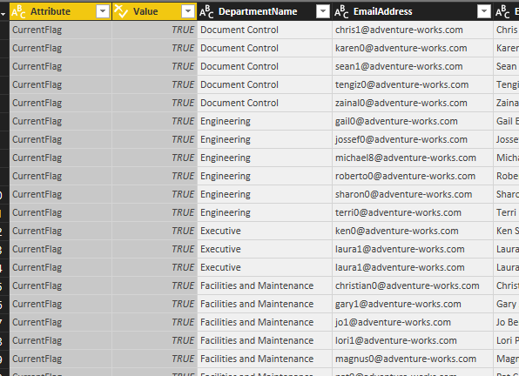

**16. Convert to List:**

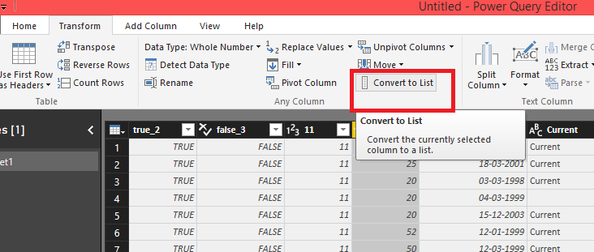

After applying Convert to list to Attribute Column:

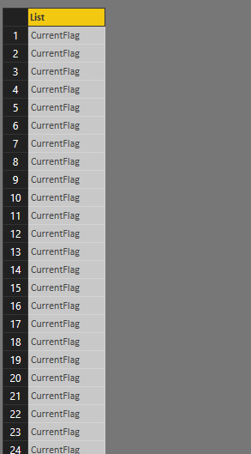

**Transformations from 11-16:**



**17. Fill:**

* Import DimEmployee as shown in Section 1.
* Select the column in which you have to fill the values.

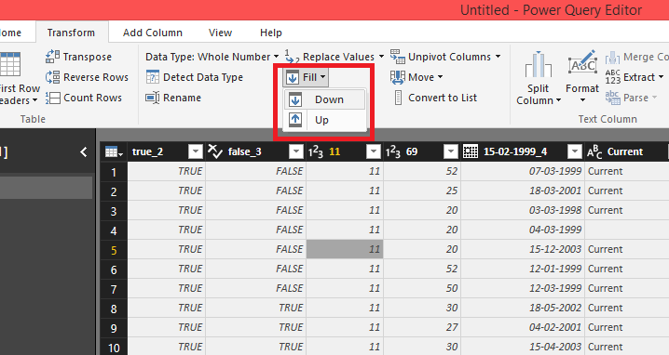

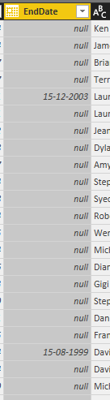

After selecting Fill Down:

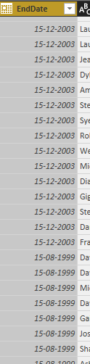

**18. Format:**

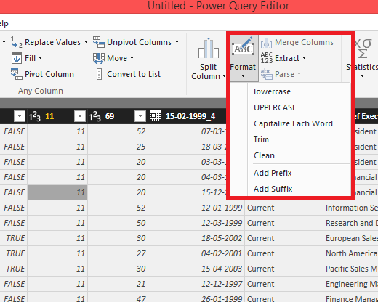

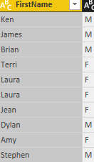

After Applying Uppercase Formatting:

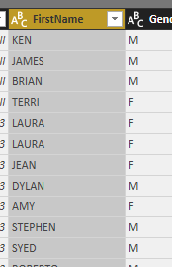

**19. Extract:**

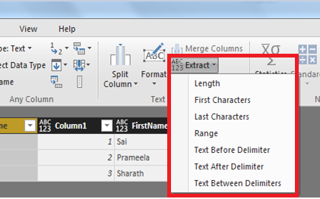

Extracting Length Of First Name:

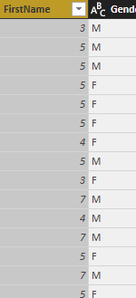

**20. Statistics:**

* Perform statistical operations like Sum, Minimum, Maximum, etc. as shown below:

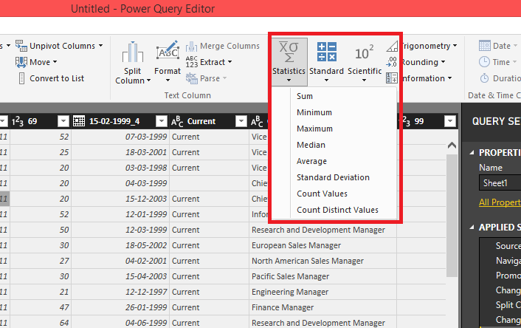

Calculating Minimum Of BaseRate:

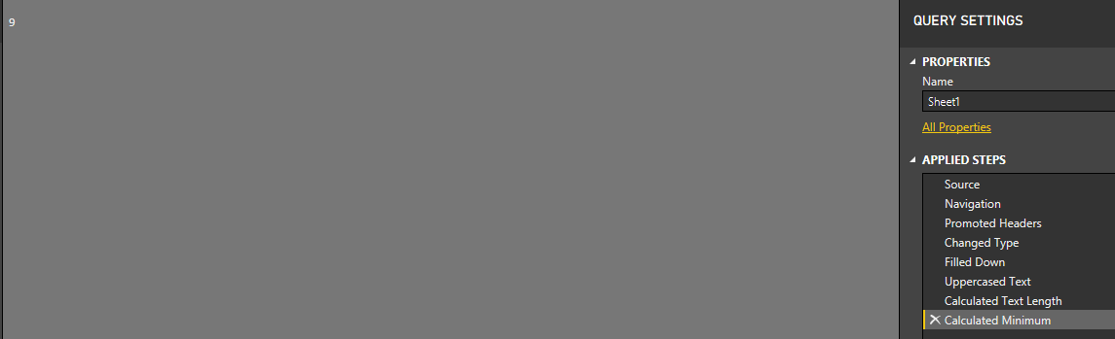

**21. Standard:**

* Perform basic math operations.

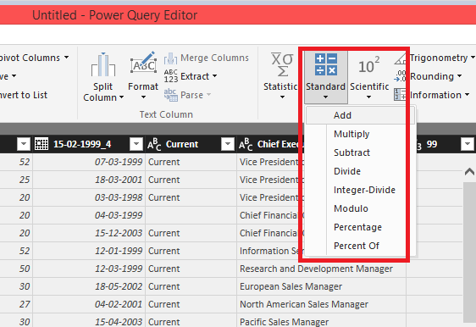

**Dividing Base Rate column by 100:**

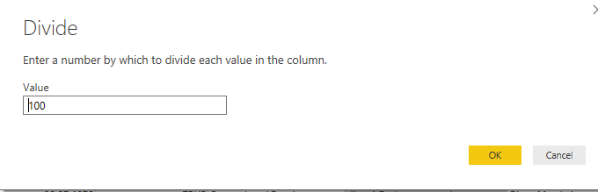

**Result:**

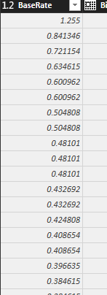

**22. Scientific:**

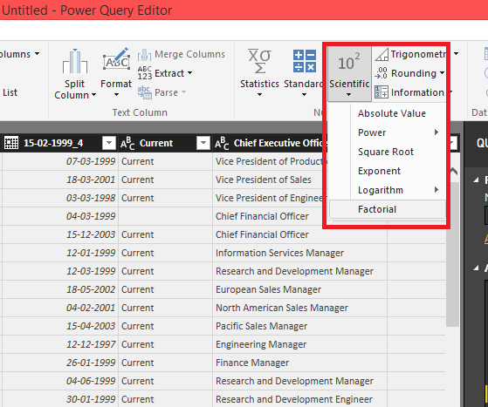

Calculating Exponent of Base Rate Column:

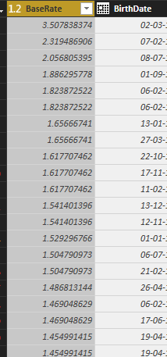

Transformation 17-22:



**23. Rounding:**

* Import DimEmployee as shown in Section 1.

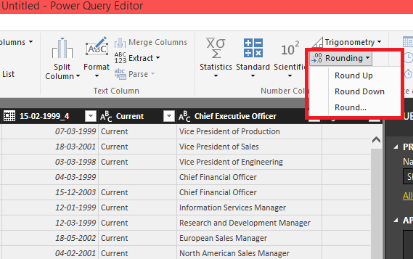

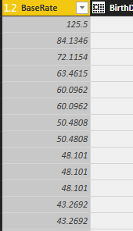 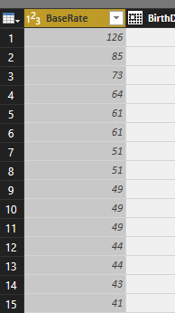

**24. Information:**

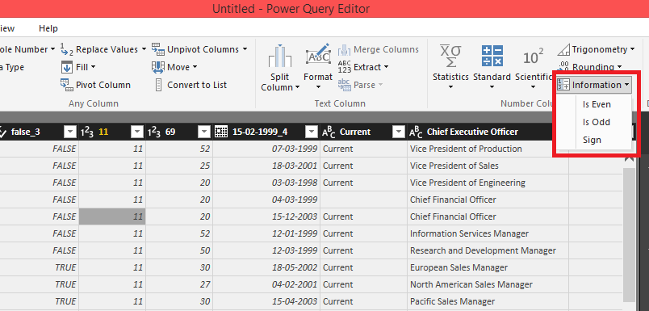

If Base Rate Information is selected to Is even:

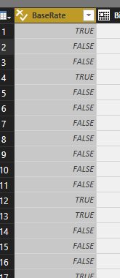

**25.** **Trigonometry:**

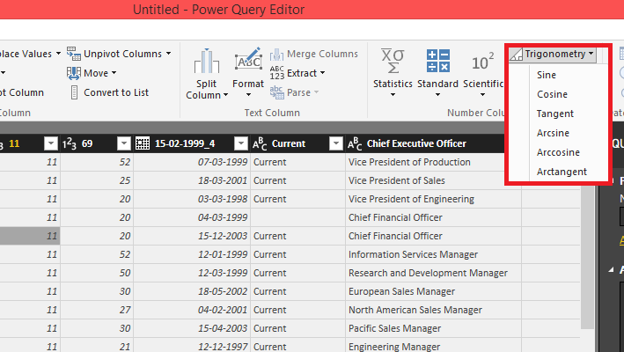

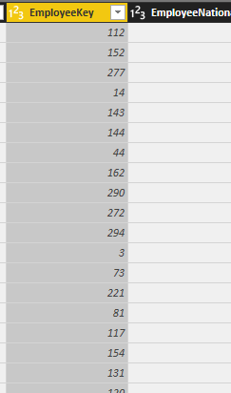

After Calculating Sine :

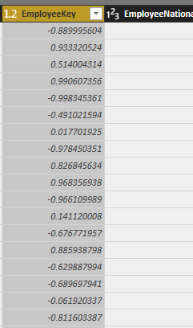

**26. Transform:**

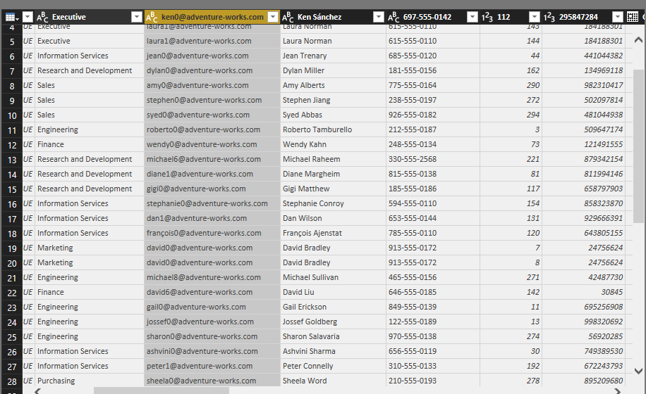

* Right Click on the column Header and a dialogue box will appear,further select transform and the transformation options will be displayed as shown below:

1. For Columns of String Data type :

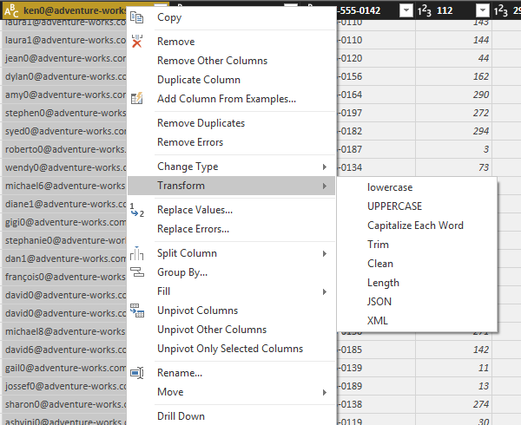

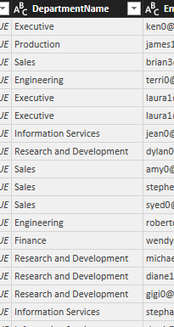

After applying Uppercase transformation on Department Column:

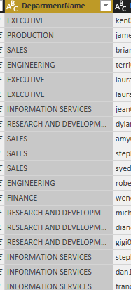

1. For Columns of Date data type:

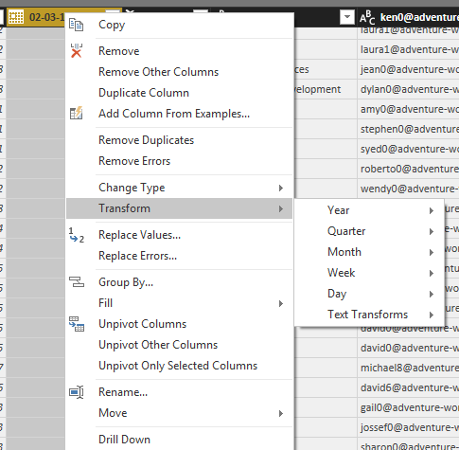

**27. Change Type:**

* Step 1 : same as above and then select Change Type:

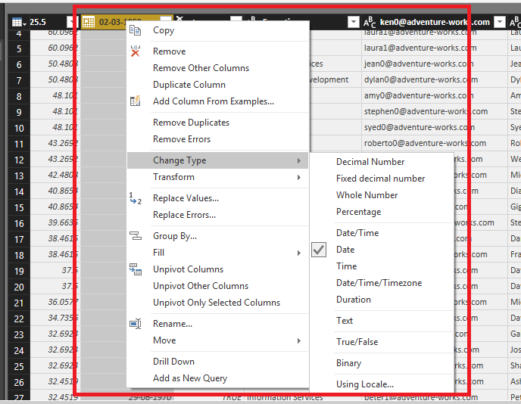

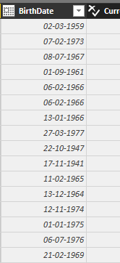

**After applying Date/Time Type to the Birth date column:**

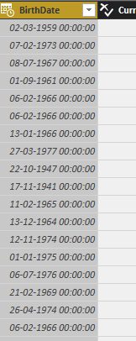

**28. Duplicate Column:**

* Step 1 as above and then select Duplicate Column.

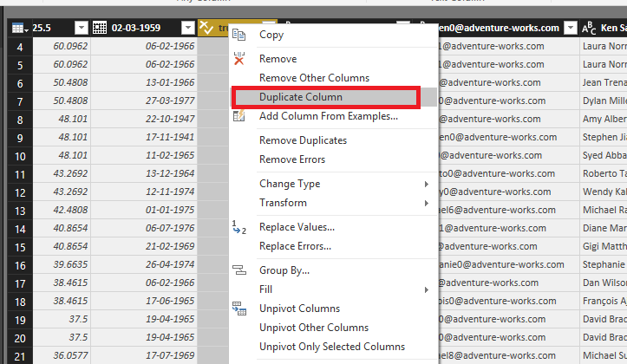

After applying Duplicate Column to email id:

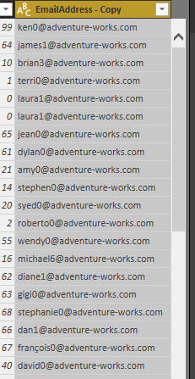

Transformations 23-28:



**Summary**

In this Lab exercise, we have learnt:

* To import data from an Excel File, Database, Online Services, Azure Services.
* To use query editor.
* To use various data transformations.